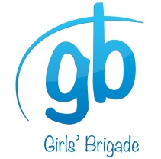
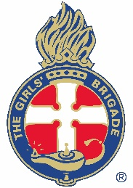
THE GIRLS’ BRIGADE NEW ZEALAND INCORPORATED
(including Girls’ Brigade and iconz4girlz)

GBNZ CODE OF CONDUCT DECLARATION FOR GB/IFG LEADERS

I have read and will comply with the GBNZ Code of Conduct.
I promise that I will serve within Girls’ Brigade (GB) or iconz4girlz (IFG) in a way that will further the aims and purpose of the organisation.

To this end I will work with girls and leaders alike in a way which:
- Ensures their welfare, safety and continuing personal development
- Respects the wishes of parents and caregivers
- Maintains the good name of Girls’ Brigade New Zealand, GB and IFG
- Reflects the standards of Christian organisations

Full Name………………………………………………………………………………………..
(Please Print)

Signed……………………………………………………………..Date…………………………

(This code applies to all adults having leadership responsibilities in Girls’ Brigade/ iconz4girlz.)

This signed declaration will be kept with Company/Unit or Area files and reviewed and re-signed along with leader’s registration renewal every three years.

